Quest for the Crown

# C:\Users\Diogo\Downloads\boxart.png

# Game Definitions

Version 1.0 – 25/05/2013

Author: Diogo Muller

<https://mail.google.com/mail/u/0/?ui=2&ik=95e362b57f&view=att&th=13f8c58858c55381&attid=0.1&disp=emb&realattid=ii_13f8c57b2e36ff16&zw&atsh=1>

|  |  |  |
| --- | --- | --- |
| **Version** | **Date** | **Comments** |
| V 0.1.0 | 25/05/2013 | Initial Version |
| V 0.1.1 | 25/05/2013 | Added data about the first iteration. |
| V 0.1.2 | 27/05/2013 | Updated with first iteration complete data and new data for the second iteration. |
| V 0.2.0 | 28/05/2013 | Added data about the second iteration. |
| V 0.2.1 | 01/06/2013 | Updated with second iteration complete data and new data for future iterations. |
| V 0.3.0 | 01/06/2013 | Added data for the third iteration. |
| V 0.3.1 | 11/06/2013 | Updated with third iteration data (without times). |
| V 0.3.2 | 12/06/2013 | Updated with third iteration times. |
|  |  |  |
|  |  |  |
|  |  |  |
|  |  |  |
|  |  |  |

# Introduction

## About the Game

Quest for the Crown will be a adventure/exploration game, based on the oldest Zelda games, with some random elements. The whole game will be made using C/C++, in a console environment.

## Basic Story

In this game, you are the prince of a distant kingdom. An evil wizard stole your crown, and if you don’t recover it soon, he’ll claim the kingdom as his own. To thwart the wizard’s evil plan, you will explore dungeons, searching for ancient artifacts that can counter-attack the evil wizard powers.

## Feature Descriptions

The game will be implemented in a cascading way, where the next step will only be implemented after the last step is fully implemented, tested, and deemed stable.

In the most basic scenario, the prince will have one weapon, his sword, and has to kill a few enemies on the screen.

On a second version, the player has to transverse a few sceneries, killing new enemies, until he reaches the evil wizard, a boss enemy.

After this basic feature is done, the next part is creating a dungeon, with a new weapon (bow and arrow), one life power up and pickup, new enemies, puzzles and a new boss character. The player must get an item after the dungeon, and only after that he can battle the evil wizard.

When the first dungeon and its items are done, the focus will be changed a bit to more technical features, them being Xbox 360 controller support and sound. No changes should be made on the game, save from those two things.

The next step is doing another extra dungeon, with a new weapon (bomb), one life power up, new enemies, puzzles and one new boss and artifact. Only after both dungeons the player will get the opportunity to battle the evil wizard.

After both dungeons are done, the next step is creating random caves/events. Those will show up randomly on pre-determined places on the map. The caves will be procedurally created, and will contain Money, Arrows, Bombs and extra health, if the player isn’t with its maximum possible health.

The last step is creating cut scenes to better tell the story, and a town, where the player can spend his money buying supplies and interact with townspeople, which can give the player interesting tips.

# Game Features

The game features are listed here, ordered by priority. Smaller priority values mean more important features.

|  |  |  |
| --- | --- | --- |
| **Feature** | **Description** | **Priority** |
| Player movement | The player can move on the screen. | 1 |
| Player attack | The player can attack enemies. | 1 |
| Basic enemy | Basic enemies to be attacked. | 1 |
| Title screen | Game title screen with game name and author. | 1 |
| Game Over Screen | Game over screen. | 1 |
| Basic GUI | Shows player name and health. | 1 |
| Location change | Player movement to other maps. | 2 |
| Different enemies | Enemies with different forms/ways of attacking the player. | 2 |
| Evil wizard | Boss character, evil wizard | 2 |
| Victory screen | A victory screen. | 2 |
| First Dungeon | Basic dungeon, with at least a few rooms and puzzles. | 3 |
| Weapon: Bow | New weapon, bow. It will launch projectiles that run the screen until they hit a wall or an enemy. | 3 |
| Pick Up: Arrows | Arrow pick up and GUI element. The player cannot use the bow if he has no arrows. | 3 |
| Pick Up: Life | Will allow the player to restore one life unity. | 3 |
| Power Up: Life | Will add one unity to the player’s life. | 3 |
| First Boss | Boss character, easier to defeat using the bow. | 3 |
| Long distance enemies. | Enemies that can attack from a long distance. | 3 |
| Controller support | Xbox 360 controller support. | 4 |
| Sound Effects | Basic sound effects – Pickup, attack, enemy hit, player hit, maybe ambient sounds. | 4 |
| Title Screen Upgrade | Add New Game, Load Game (Optional, if can be easily done), How to Play and Exit Game to the title screen | 4 |
| Save/Load Game option | Create a Save/Load game option. The enemies and areas may be reset, but at least boss data, weapon data and dungeon complete data may be saved. | 4 |
| Second Dungeon | Bigger dungeon, with more puzzles and keys. | 5 |
| Pick Up: Keys | Keys to open closed doors. | 5 |
| Stronger enemies | Enemies that need more than one attack to be killed. | 5 |
| Weapon: Bombs | Bombs will kill every enemy on its blast radius, and can open hidden rooms. | 5 |
| Second Boss | Easier to kill using bombs. | 5 |
| Procedurally generated Caves | Will have enemies and at least one treasure. | 6 |
| Random Events | Can give the player more items, or power ups. | 6 |
| Power up: Extra arrows | Allows the player to carry more arrows. | 6 |
| Power up: Extra bombs | Allows the player to carry more bombs. | 6 |
| Pick up: Money | Money, to be used as points or to buy items. | 6 |
| Store | Store, can be used to buy Power ups and refills, use money. | 6 |
| Cut scenes | Tell the player the game story. | 7 |
| NPCs | Can interact with the player. | 7 |
| Towns | Where the player can buy things and talk to NPCs. | 7 |
| Rebalancing | Game rebalancing, testing the enemies new abilities and where they are placed. | 8 |
| New features | Study new features. | 8 |

# Characters

The game will initially have the main character and one basic type of enemy, with more types being added on the next iterations.

|  |  |  |  |
| --- | --- | --- | --- |
| **Name** | **Appearance** | **Description** | **Alignment** |
| The Prince | @ | You, the main character. | Good |
| Slimes | o | Most basic, weak, puny enemies. | Evil |
| Goon | 8 | Still weak, but faster than the slime. Now they can throw javelins at you. | Evil |
| Bat | ~ | Weak but very fast. | Evil |
| Vermin | OOOOOOOOOO | Big vermin, can split itself if hit. | Evil |
| Evil Wizard | W | The most evil, cruel last boss ever. Teleports and throws fireballs at you. | Evil |

# The World

## Basic Description

The game world consists of nine areas. Each area has one of five themes: Field, Cave, Beach, Temple and Boss. There are three field locations, two cave and temple locations, and one beach and boss location. The World is basically divided as follows:

|  |  |  |
| --- | --- | --- |
| [1] | [2] | [3] |
| [4] | [5] | [6] |
| [7] | [8] | [9] |

Where Green represents fields, Red represents caves, Yellow represents beach, Blue represents temple and Black represents boss. Also, note that not every area is connected with all of its adjacent areas. Area 9, for example, is only connected with area 8, while area 7 is only connected with area 4.

## Areas Details

In this session, each area will be descripted, according to the following legend:

|  |  |
| --- | --- |
| **Symbol** | **Meaning** |
| S | Character starting position |
| # | Wall |
| o | Slime |
| B | Goon |
| O | Vermin (part) |
| W | Evil Wizard |
| ~ | Water |
| L | Locked Door (must defeat all enemies to open) |
| G | Non-walkable grid |
| D | Item: Bow. |
| + | Pickup: Health |
| = | Pickup: Arrows |
| 1 | Dungeon 1 Entrance – Beach cave |
| 2 | Return to world map: Dungeon 1 Entrance |

## World map

|  |  |
| --- | --- |
| Area 1 | Field |
| ################################################################################  #  # o  # o  #  #  #  #  #  #  # o o  #  #  #  #  #  #  # o  # o  #  #  #  # # | |
| A very simple starting area, very open so the player can move freely, and with a few enemies, so the player can get a bit of combat practice. May have a tutorial, NPC or cutscene on future iterations. | |

|  |  |
| --- | --- |
| Area 2 | Field |
| ################################################################################  ######################################################  #############################################  #####################################  ################################  o #######################  o ################  #########  #####  o ######  o ####  o #####  #####  ####  #####  o ######  o o    #################  ###########################  ####################### ###################################  ############################## #######################################  ##################################### ######################################### | |
| This area is the frontier between the fields and the caves and the temple. A bit more closed, but still pretty open, and still with few enemies. A bit harder than the first area. | |

|  |  |
| --- | --- |
| Area 3 | Caves |
| ################################################################################  ######## o #############  ####### o ############  ##### o ########################### #############  #### ########################### #############  ##### o ########################### #############  #### ############################o ############  ### o ############################ #############  ### o ############################# ############  ##### ########################### ############  ############# ########################################### ################  ############# ########################################## #################  ########## ################################### o #######  ######## ################################# ######  ######## ##################################### o #####  ######## ##################################### #####  ######################################## o o ######  ######################################### #######  ############################################################ ################  ##################################### ############# ################  ##################################### ## #################  ##################################### ######## o ##################  ##################################### ######################################### | |
| A bit more closed than the field, and with a lot more enemies, the player will have to take care so he’s not ambushed by an enemy on any of the corridors. This area may have a random entrance to one of the procedurally generated levels, on a future iteration. | |

|  |  |
| --- | --- |
| Area 4 | Field |
| # #  # #  #  # o ##  # ## ## #  # ## o #  # #  # ## #  # ## #  # o #  # o #  # #  # o ## o #  # ## #  # #  # #  # ## o o #  # ## #  # ## #  # ## ## o #  # ## #  # #  # # | |
| An open field, with a few obstacles, and a few enemies. Still pretty open, may house an secret entrance on future iterations. | |

|  |  |
| --- | --- |
| Area 5 | Temple |
| #################################### #########################################  #################################### #########################################      #################################### #########################################  #################################### #########################################  # #  # #  # 8 8 8 8 #  # #  # o o o o #  # #  # 8 8 8 8 #  # #  # o o o o #  # #  # 8 8 8 8 #  # #  # o o o o #  # #  #LL## #  # #############################################################################  # ############################################################################# | |
| Temple entrance, heavily guarded. The player must defeat every enemy before he can go forward. | |

|  |  |
| --- | --- |
| Area 6 | Caves |
| #################################### ##########################################  #################################### ##########################################  ############################### #########################################  ############################### ########################################  ##### ############################## ########################################  ###### ############################ ########################################  ###### ################  ##### #######  ##### ########  #### 8 ########  #### 8 ########  ### o ########  ### ########  #### #######  #### #######  ##### o o #########  ###### ##########  ######## ###########  ############ ################  ################## 8 #####################  ########################### ###############################  ################################################################################  ################################################################################ | |
| Simple and open cave. May house a dungeon entrance on future iterations. | |

|  |  |
| --- | --- |
| Area 7 | Beach |
| # #  # #  # ##  # ##  # # #  # # ##  ## ###### ###  ### ###### ##  # ##11## ###  # ##  ## ##  ## #  ### ##  ### ###  ## # # ###  ### ##  ### ###  ### ####  ## ####  ## ##  ~~~~~~~~~~~~~~~~~~~~~~~~~~~~~~~~~~~~~~~~~~~~~~~~~~~~~~~~~~~~~~~~~~~~~~~~~~~~~~~~  ~~~~~~~~~~~~~~~~~~~~~~~~~~~~~~~~~~~~~~~~~~~~~~~~~~~~~~~~~~~~~~~~~~~~~~~~~~~~~~~~  ~~~~~~~~~~~~~~~~~~~~~~~~~~~~~~~~~~~~~~~~~~~~~~~~~~~~~~~~~~~~~~~~~~~~~~~~~~~~~~~~ | |
| Calm beach with only one enemy. May house a dungeon entrance on a future iteration. | |

|  |  |
| --- | --- |
| Area 8 | Temple |
| # #############################################################################  # # # # 8 o #  # # ###### # ####### # 8 8 o #  # # # # # # # # # ########################### ##################  # # # ## # # # # # # o o #  # # ## # # # # # #o # ############################################  # # # # # # # # o o #  # # 8 # # # # ########################################### #  # # # # ##### # # 8 # o 8 #  # # ## # # # # # ######################################  # # # # ##### # # # # 8 #  # # ## # 8 # # o# ######### # ############# ############  ####### # # # # # # # # o  # 8 # # # # # # ######### # ###################  ######## ###### # # # 8# # 8 # # o # ####  # # # # # # # # ################## # # #  # ############# # # # # # ##### # # # #  # o # #### ### ##### # # # # # # # #  ############# ##### # o # # # ############ ######### # # #  # # # 8 # # # o # # #  # ############# # # #################### ########################## # #  # 8 # # o #  ################################################################################ | |
| A labyrinth, the objective of this part is to make the player think about the different ways he can get to the exit, and find a way that better fits his objectives, be it fight with less or more enemies. There are multiple way outs. | |

|  |  |
| --- | --- |
| Area 9 | Temple |
| ################################################################################  # #  # #  # #  # #  # #  # #  # #  # #  # #  # #  #### #  W #  #  #### #  # #  # #  # #  # #  # #  # #  # #  ################################################################################ | |
| Boss battle. Open area, may be decorated or change places on future versions. | |

## Dungeon 1 – Beach Caves

The beach caves are a short, easy dungeon, where the player can get the bow. There are a few grids where the player cannot walk into, but his arrows can go through. The boss is a giant worm inside a cage, with fixed patterns.

|  |  |
| --- | --- |
| [3] | [5] |
| [2] | [4] |
| [1] |  |

|  |  |
| --- | --- |
| Area 1 | Dungeon |
| ##################################### #########################################  # #  # #  # #  # #  # #  # ^ ^ #  # #  # #  # #  # #  # #  # #  # ^ #  # #  # #  # ^ ^ #  # #  # #  # #  # #  # #  #####################################22######################################### | |
| Initial area, a few bats. | |
| Area 2 | Dungeon |
| ##################################### #########################################  # G #  # G #  # G #  # B G #  # G #  # G #  # G #  # G #  # B G #  # G #  # B G  # G  # B G #  # G #  # G #  # G #  # G #  # B G #  # G #  # G #  # G #  ##################################### ######################################### | |
| At first, the player may be confused by this part. The grids can only be passed by arrows. | |

|  |  |
| --- | --- |
| Area 3 | Dungeon |
| ################################################################################  # #  # #  # B #  # #  # #  # #  # GGGGGGGGGGGGGGGGGGGGG #  # G G #  # B G G B #  # G D G #  # G G #  # G G #  # G G #  # G G #  # G G #  # B G G B #  # G G #  # G G #  # G G #  # G G #  # G G #  ##################################### ######################################### | |
| Here, the player gets the bow, and may experiment with shooting past the grids. | |

|  |  |
| --- | --- |
| Area 4 | Dungeon |
| ##################################### #########################################  # G #  # G #  # G ^ #  # B G #  # G ^ #  # G #  # G #  # G ^ #  #GGGGGGGGGGGGGGGGGGGGGGGGGGGGGGGG #  # ^ #  ^ #  #  # ^ #  #GGGGGGGGGGGGGGGGGGGGGGGGGGGGGGGG #  # G #  # G ^ #  # G ^ #  # B G #  # G #  # G #  # G #  ################################################################################ | |
| A bit more enemies, a few goons. Nothing too hard, but still the biggest number of enemies on the dungeon. | |

|  |  |
| --- | --- |
| Area 5 | Dungeon |
| ################################################################################  # #  # #  # #  # #  # #  # #  # #  # #  # #  # #  # #  # #  # #  # #  # OOOOOOOOOOOOOOOOOOOOOOOOOOOOO #  # #  #GGGGGGGGGGGGGGGGGGGGGGGGGGGGGGGGGGGGGGGGGGGGGGGGGGGGGGGGGGGGGGGGGGGGGGGGGGGGGG#  # #  # #  # #  # #  ##################################### ######################################### | |
| Boss. You must kill every part of it to defeat him. | |

# First Iteration

## Time and Activities

Every objective was completed on the first iteration. The biggest part of the iteration was implementation, with documentation also taking a good part of the time. The time breakdown is as follows:

|  |  |
| --- | --- |
| **Activity Type** | **Time** |
| Basic Setup | 0:29:00 |
| Documentation | 1:46:00 |
| Study | 0:21:00 |
| Implementation | 8:03:00 |
| Design | 0:32:00 |

The activities of this iteration where:

|  |  |  |
| --- | --- | --- |
| **Feature** | **Description** | **Status** |
| Player movement | The player can move on the screen. | Done |
| Player attack | The player can attack enemies. | Done |
| Basic enemy | Basic enemies to be attacked. | Done |
| Title screen | Game title screen with game name and author. | Done |
| Game Over Screen | Game over screen. | Done |
| Basic GUI | Shows player name and health. | Done |

And a more detailed activity breakdown, with times:

|  |  |  |  |
| --- | --- | --- | --- |
| **Date** | **Activity** | **Observation** | **Delta Time** |
| 25/05/2013 | Basic Setup | Project creation, folder structure, library importing. | 0:07:00 |
| 25/05/2013 | Documentation | Game basic definitions. | 0:56:00 |
| 25/05/2013 | Design | Game design decisions and basic design documentation. | 0:32:00 |
| 25/05/2013 | Basic Setup | Git Repository setup and initial commit. | 0:13:00 |
| 25/05/2013 | Study | Console lib study. | 0:12:00 |
| 25/05/2013 | Implementation | First iteration. (Main loop created) | 1:05:00 |
| 25/05/2013 | Basic Setup | Set primitive bug reporting system. | 0:03:00 |
| 26/05/2013 | Implementation | First iteration. (GameObject, Enemy and Player classes, simplified game loop). | 1:37:00 |
| 26/05/2013 | Study | Keyboard input study. | 0:09:00 |
| 26/05/2013 | Implementation | First Iteration. Player movement and positioning control. | 1:08:00 |
| 26/05/2013 | Basic Setup | Git ignore file. | 0:06:00 |
| 26/05/2013 | Implementation | First Iteration. (GameManager) | 1:38:00 |
| 26/05/2013 | Implementation | First Iteration. (Enemy and Player hit, attack, and Health. Game Over condition added.) | 2:13:00 |
| 26/05/2013 | Implementation | First Iteration. (Title Screen and Game Over Screen. First Iteration end.) | 0:22:00 |
| 27/05/2013 | Documentation | Game design document update. (First Iteration detailing) | 0:50:00 |

## Resulting Game

The end result was a simple playable game with title, game and game over screens. As the game starts, the first screen that greets the player is the following title screen:

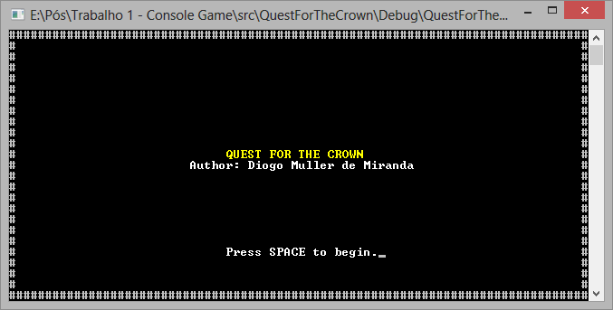

Title screen

After pressing the SPACE key, the game begins, and the player starts the game on a screen with a few enemies. After the game starts, and every time the player is hit, he glows yellow and gets invulnerable for a few milliseconds.

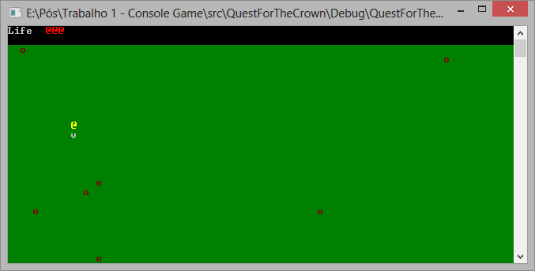

Basic Gameplay – Player Invulnerable State

After those few milliseconds, the player regains its normal color, and can be hit. If the player loses 3 points of life, he dies.

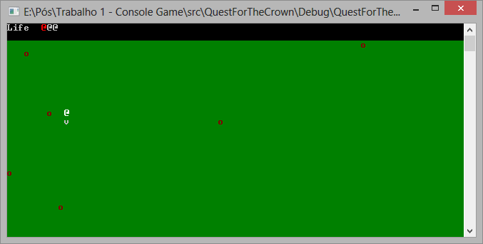

Basic Gameplay – Player Normal State. Notice the player was already hit twice in this case.

The objective of the game is to kill every enemy, and to do that, the player character can use a basic attack with a range of 3 units. If the enemy is hit by any of the three sword parts, it dies.

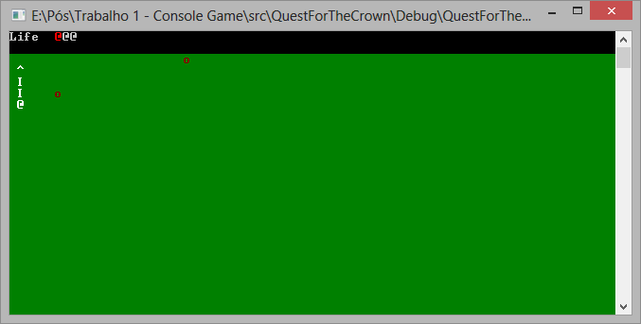

Basic Gameplay – Attack Animation

If the player loses all of its health or kills all the enemies, the game state changes to Game Over, and the game over screen is presented to the player, where he can hit the space bar to finish the game.

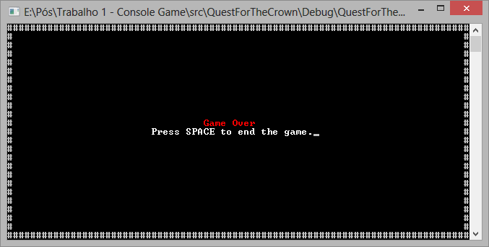

Game over screen.

On the future, one change that can be made is making the Game Over screen redirect to the title screen, if possible.

## Reflections and Lessons Learned

On this first iteration, most of the time was spent with implementation, as expected. The whole iteration took about double the time I thought it would at first, and also some of the Basic Setup items and Documentation took more time than it was first expected, but the final results where far better than what was planned on the start.

A very good lesson that can be learned from this iteration is that I shouldn’t be afraid of redoing big chunks of code, and that sometimes the best code is the one that works well, and you can understand it well, even if it’s not the most efficient or the most elegant solution you could think of.

# Second Iteration

## Time and Activities

Every objective was completed on the second iteration. Again, implementation was a big part on this iteration time breakdown, with design also getting a lot of attention:

|  |  |
| --- | --- |
| **Activity Type** | **Time** |
| Basic Setup | 0:00:00 |
| Documentation | 1:55:00 |
| Study | 0:04:00 |
| Implementation | 12:36:00 |
| Design | 2:17:00 |

This iteration may had less activities, but “Location change” was more time consuming than the entire previous iteration, and also caused big changes on the game core:

|  |  |  |
| --- | --- | --- |
| **Feature** | **Description** | **Status** |
| Location change | Player movement to other maps. | Done |
| Different enemies | Enemies with different forms/ways of attacking the player. | Done |
| Evil wizard | Boss character, evil wizard | Done |
| Victory screen | A victory screen. | Done |

And here is an activity breakdown with times:

|  |  |  |  |
| --- | --- | --- | --- |
| **Date** | **Activity** | **Observation** | **Delta Time** |
| 27/05/2013 | Design | Level design (Basic geography, screens 1 to 5.) | 1:23:00 |
| 28/05/2013 | Design | Level design (Screens 6 to 9.) | 0:54:00 |
| 28/05/2013 | Documentation | Game Description and Game Design update with Iteration 2 data | 0:56:00 |
| 29/05/2013 | Study | Study of the games using the console lib. | 0:04:00 |
| 30/05/2013 | Implementation | Second Iteration. (Level class, base code changes) | 2:02:00 |
| 30/05/2013 | Implementation | Second Iteration. (Changes in Draw method) | 0:44:00 |
| 30/05/2013 | Implementation | Second Iteration. (Level, gameplay changes, removed attack.) | 1:18:00 |
| 30/05/2013 | Implementation | Second Iteration. (Maps, change between them.) | 3:05:00 |
| 31/05/2013 | Implementation | Second Iteration. (Bugfixes, Weapon base.) | 1:21:00 |
| 31/05/2013 | Implementation | Second Iteration. (Part of weapon implementation.) | 2:10:00 |
| 31/05/2013 | Implementation | Second Iteration. (Weapon reimplemented.) | 1:13:00 |
| 31/05/2013 | Implementation | Second Iteration. (Victory screen and conditions. Second iteration end.) | 0:43:00 |
| 01/06/2013 | Documentation | Game design document update (second iteration complete.) | 0:59:00 |

As an unforeseen activity, the weapon system had to be rewritten, also taking a big chunk of time. The good part is that the code is generic enough now that it can be used to implement other weapons on future iterations, with no changes, or at least very small ones.

The draw code was also revised, and now only the player and the GUI are redrawn at every frame, while every other object is only redrawn when there are changes. In the future, we may also change it so the GUI is not redrawn at every frame.

## Resulting Game

The end result was a game similar to the previous iteration. Some changes had to be made with the game core, with the spacebar attack being ditched in favor of a four directions attack, using the arrow keys on the keyboard. Also, the game now has new scenery details, enemies and places to explore:

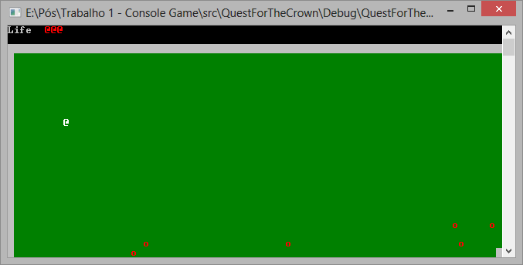

First screen, revised

If the player goes to any open border on the map, he is sent to the neighboring map on that direction. There are four types of ambient on the game: Fields (green), Caves (Red), Temple (Blue) and Beach (Yellow). Also, the boss room has a special color, Black.

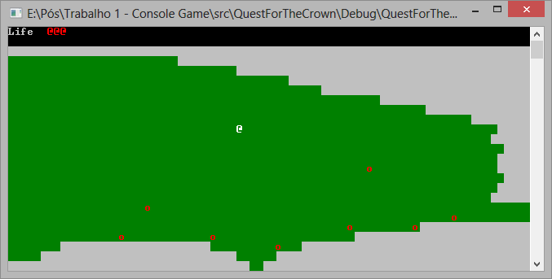

Field map

The fields are very open terrains, with few enemies and very easy movement.

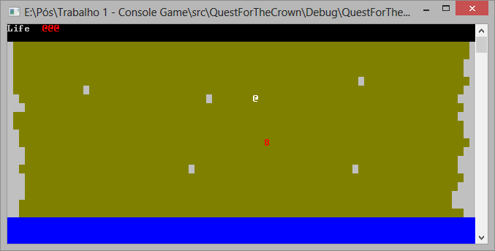

Beach map

The beach also has a very open terrain, with even fewer enemies, and some water. The player can’t swim, so only the yellow areas are navigable.

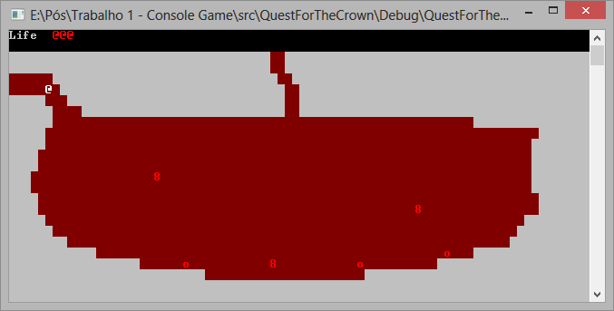

Caves map

The caves consist of very irregular maps, sometimes very closed and sometimes very open, with a few more enemies than the field and the beach.

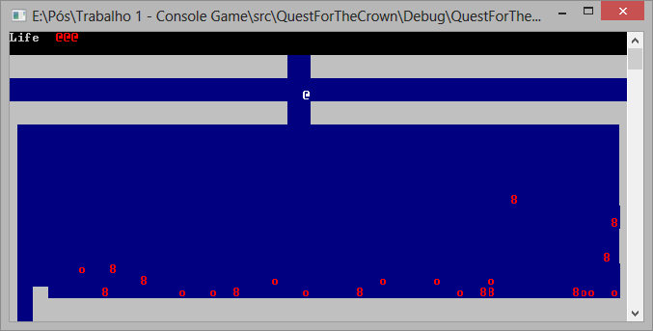

Temple map

The temple consists of regular forms, sometimes open and sometimes very, very closed terrains, and a big number of enemies.

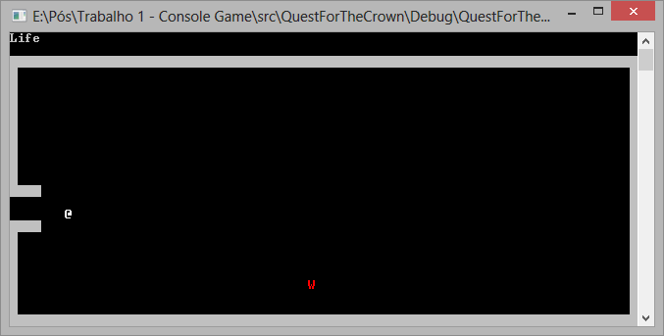

Boss map

The boss room is a big, empty room where the only enemy is the boss character. If the player defeats him, he is presented with a victory screen:

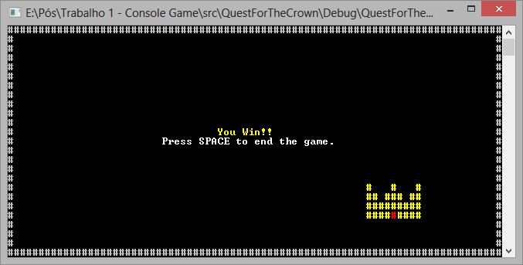

Victory screen

On the next iterations, one change that may be made is putting the game credits on the victory screen, and make it and the game over screen return to the title screen.

## Reflections and Lessons Learned

On this iteration, a lot of time was spent rewriting code for existing features that broke when something changed. The draw code was rewritten so it could be more efficient, but doing so broke the weapon drawing code. Since the next iterations will use new weapons, instead of fixing the old weapon code, I ditched it and rewrote if from scratch. I think the result, at least for now, is pretty good, and the same code can be reused as a bow code, with little to no changes.

A lesson that can be taken here is, while coding things to work, without thinking about the future, may be very efficient for game implementation, it can cause some rework and rewrites. Maybe a good approach is doing generic code at some level, while being less zealous with very specific code that simply makes the game work. In its current state, the game follows this philosophy, and it’s working pretty well, with very few parts that may need to be rewritten from scratch.

Also, I had some new ideas for the game, which may be implemented on a new iteration, probably between iterations 3 and 4. Most of them are pretty technical, but will give the game a new level of polish.

# Third Iteration

## Time and Activities

Every objective was completed on the third iteration, again with a biggest focus on implementation. The time breakdown is as follows:

|  |  |
| --- | --- |
| **Activity Type** | **Time** |
| Basic Setup | 0:00:00 |
| Documentation | 2:32:00 |
| Study | 3:28:00 |
| Implementation | 12:17:00 |
| Design | 2:17:00 |

The activities of this iteration where:

|  |  |  |
| --- | --- | --- |
| **Feature** | **Description** | **Status** |
| First Dungeon | Basic dungeon, with at least a few rooms and puzzles. | Done |
| Weapon: Bow | New weapon, bow. It will launch projectiles that run the screen until they hit a wall or an enemy. | Done |
| Pick Up: Arrows | Arrow pick up and GUI element. The player cannot use the bow if he has no arrows. | Done |
| Pick Up: Life | Will allow the player to restore one life unity. | Done |
| Power Up: Life | Will add one unity to the player’s life. | Done |
| First Boss | Boss character, easier to defeat using the bow. | Done |
| Long distance enemies. | Enemies that can attack from a long distance. | Done |

And a more detailed activity breakdown, with times:

|  |  |  |  |
| --- | --- | --- | --- |
| **Date** | **Activity** | **Observation** | **Delta Time** |
| 01/06/2013 | Design | Level design (Enemies and world redesign, dungeon first draft) | 1:10:00 |
| 01/06/2013 | Design | Level design (Dungeon, feature definitions) | 0:49:00 |
| 02/06/2013 | Implementation | Third Iteration. (Enemy AI and changes to GameObject position) | 1:43:00 |
| 02/06/2013 | Implementation | Third Iteration. (Barebones dungeon code) | 0:59:00 |
| 02/06/2013 | Implementation | Third Iteration. (Dungeon navigation) | 1:50:00 |
| 03/06/2013 | Implementation | Third Iteration. (Enemy projectile, generic projectile) | 1:21:00 |
| 04/06/2013 | Study | Study for diverse bugfixes and better performance. | 0:38:00 |
| 04/06/2013 | Implementation | Third Iteration. (Bugfixes) | 0:37:00 |
| 05/06/2013 | Implementation | Third Iteration. (Bow Implementation) | 0:52:00 |
| 05/06/2013 | Study | Keyboard buffer study. | 0:11:00 |
| 05/06/2013 | Implementation | Third Iteration. (Title Screen options, How to Play, Reset game at Game Over). | 1:13:00 |
| 06/06/2013 | Implementation | Third Iteration. (Health pickup, Weapon has to be obtained, small bugfixes) | 2:01:00 |
| 08/06/2013 | Implementation | Third Iteration. (Dungeon ending, colors changed) | 1:26:00 |
| 09/06/2013 | Implementation | Third Iteration. (Bow ammunition and pickup. Second iteration end.) | 0:25:00 |
| 11/06/2013 | Documentation | Game design document update, without times. | 0:30:00 |
| 12/06/2013 | Documentation | Game design document update (third iteration complete). | 0:14:00 |

## Resulting Game

First of all, the title screen was changed, and new options where added:

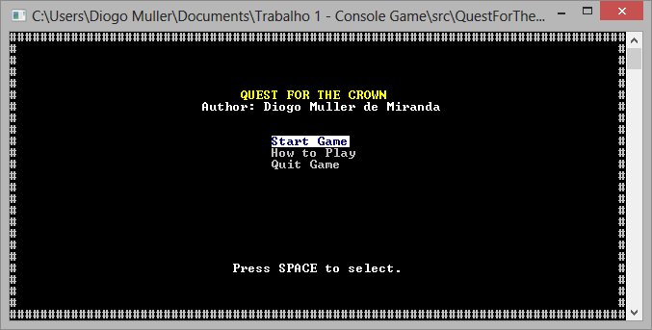

Title screen

And a new tutorial section, called “How to Play”, was added, with game commands:

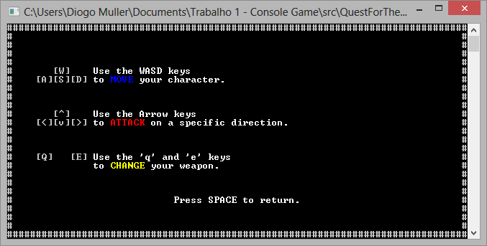

How to Play screen

On the game, the beach area was changed, with a new cave being put on it.

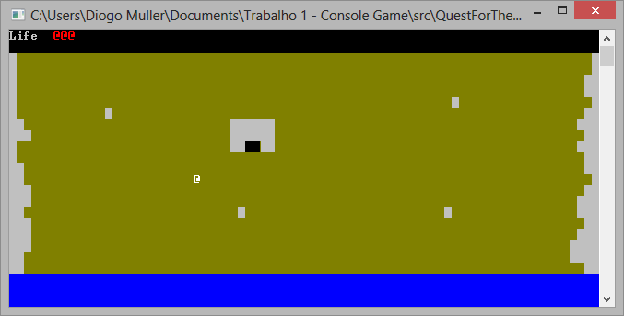

Beach area, with the new cave.

When the player enters the cave, he is teleported to the entrance of the dungeon, where he can meet one of the new enemy types.

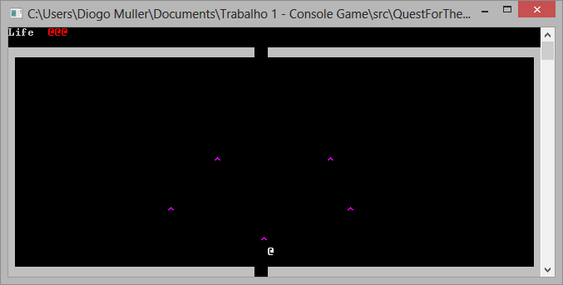

Dungeon – Entrance

The goon enemies where changed, and now they can use projectile weapons. Those can hurt the player, and they can use this attack once every few seconds. Also, a new wall type was added, the grid, where projectiles can go through, but the players and enemy can’t.

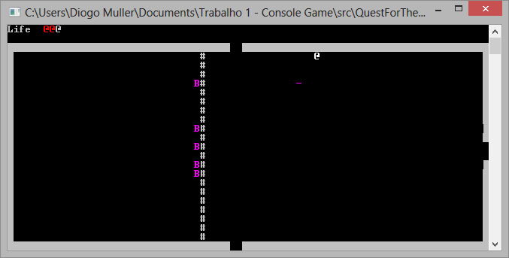

Dungeon – Goon attacking.

On the northest part of the dungeon, the player can get the bow.

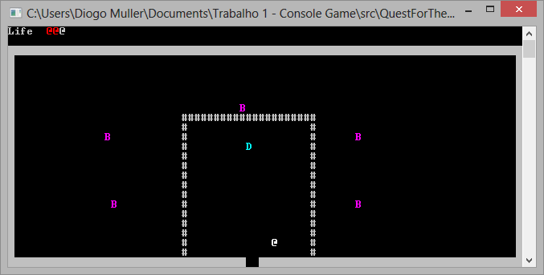

Dungeon – Bow.

And after the player gets the bow, he can change the weapon with the ‘q’ and ‘e’ buttons. The bow has limited ammo, and the GUI changes a bit to show the weapon and ammo info.

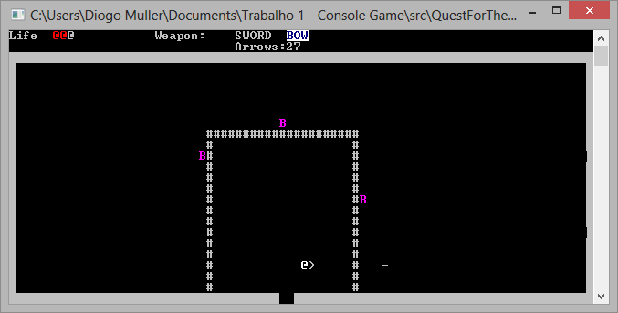

Dungeon – Player shooting the bow

Also, the enemies can drop Arrow (=) and Health (+) recovery items, when they die.

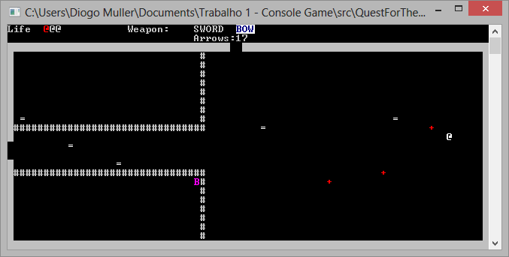

Dungeon – Pickups

A new boss was added, the worm. The player must kill all of its parts to defeat it for once and for all.

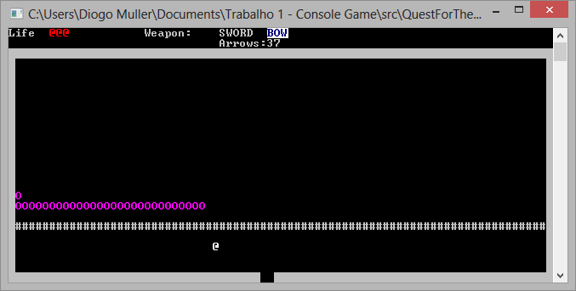

Dungeon – Boss (Worm)

Once the boss is defeated, the player is teleported out of the dungeon, with extra health and the temple area unlocked.

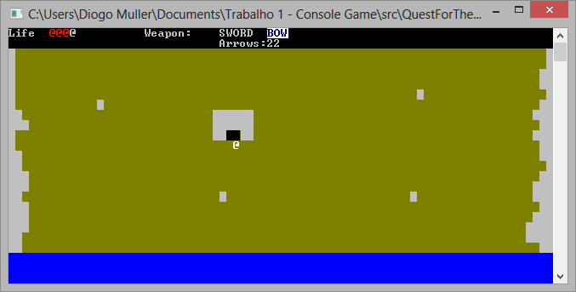

Dungeon entrance – After the boss

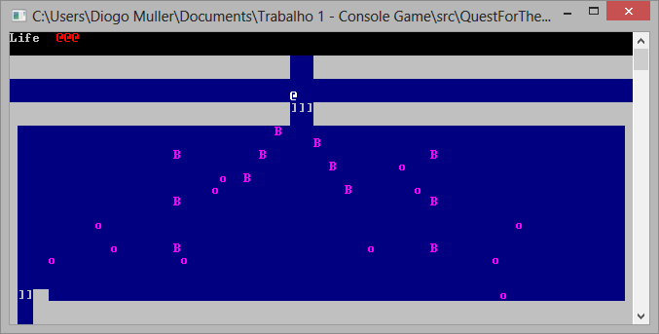

Temple Area – Before Dungeon

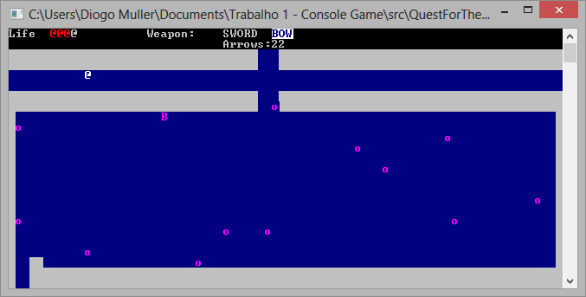

Temple Area – After Dungeon

## Reflections and Lessons Learned

For various reasons, this iteration took more days to complete – even if it took more or less the same time as the previous iterations to complete. The development was mostly smooth, and a lot of features where pretty easy to implement, thanks to previous considerations on the code.

Since some changes were made with the GUI, I took the liberty to change the title screen and add a tutorial. Some changes were also made in the game, taking in consideration input from players. That proved to be valuable, and the game is a lot better now, because of that.

Now, the game is on a very playable state, and I had a few new ideas for the next iteration – where I’ll work on more technical features and game polishing. One thing that was noticed on this iteration is that the number of bugs grew when the game complexity grew, and the game will probably need a few more playtests and bugfixes after the next iteration, so it can be ready to be delivered.

Anyway, the dungeon and bow implementation are easy enough that new weapons and dungeons can be easily added in a lot less time than this first dungeon. There are still some things to do, but the game is pretty much nearing completion.